Adam Steen

id: 18103368

Robotic Process Automation

The Future of Work

Student Name: Adam Steen

Student ID: 18103368

A Research Project submitted in partial fulfilment for the Postgraduate Diploma in Innovation Management

National University of Ireland, Galway June 2019

I hereby certify that this material, which I now submit for assessment on the programme of study leading to the award of Postgraduate Dip. in Innovation Management is entirely my own work and has not been taken from the work of others save and to the extent that such work has been cited and acknowledged within the text of my work.

Name: Adam Steen

Table of Contents

Executive Summary 3

1. Introduction 4

2. Literature Review 5

2.1 Introduction 5

2.2 What is RPA (Robotic Process Automation), definition misperceptions 5

2.3 What is a software robot? 6

2.4 Target sector for RPA 7

2.5 Implementation of the RPA 8

2.6 Benefits (Advantages) of RPA 12

2.7 Disadvantages of RPA 13

3. Research Methodology 15

3.1 Background 15

3.2 Survey (questionnaire) design 15

3.3 Participants and sample selection 17

3.4 Survey delivery 18

4. Results and Findings 19

5. Discussion of Results 24

5.1 Introduction 24

5.2 Figure 6 – Survey question 1 24

5.3 Figure 7 (a) and (b) - Survey question 2 24

5.4 Figure 8 - Survey question 3 25

5.5 Figure 9 - Survey question 4 25

5.6 Figure10 - Survey question 5 25

5.7 Figure 11 - Survey question 6 25

5.8 Figure 12 - Survey question 7 26

6. Conclusion and Recommendations 27

6.1 Conclusions 27

6.2 Recommendation 27

Bibliography 28

Appendix 29

Table of Figures

Figure 1: BPM vs RPA, Adapted from Forrester Research (2014) (LeClair, 2017) 6

Figure 2: The popularity of robotic process automation has skyrocketed in recent years. Source: Google Trends (HELPSYSTEMS, 2017) 6

Figure 3: Part of Journey towards machines replacing humans (Institute, 2017) 8

Figure 4: Structured approach to process optimization (Institute, 2017) 9

Figure 5: Delivery Methodology – Key Deliverables (Willcocks, et al., 2015) 12

Figure 6: Survey Results - question 1 19

Figure 7: Survey results - question 2 20

Figure 8: Survey Results - question 3 21

Figure 9: Survey Results - question 4 22

Figure 10: Survey Results - question 5 22

Figure 11: Survey Results - question 6 23

Figure 12: Survey Results - question 7 23

Figure 13: The Survey used in the research 29

Figure 14: Placement of the Survey 30

# Executive Summary

Robotic Process Automation (RPA) is an emerging technology for automating high volume, low-value tasks. This research is highlighting the nature of this technology where and when it can be used. It suggests its areas of implementation and what benefits and disadvantages are involved as a result of this trend in technology. The term automation has created a lot of concern among manpower and it is believed that the advancement of technology causes unemployment by replacing manpower with machines to perform the required tasks which were explored in this research by measuring the level of concern among the respondents and their awareness of how technology implementation impacts their job situation.

Working professionals are positive towards implementing new technologies within their working environment despite the concern of losing their jobs. There should be an adoption of a new vision to integrate the manpower with the technology implementation in the workplace to form an interactive entity which increases the productivity, wellness and development of the working professionals.

# Introduction

This research is trying to outline the evolving concept of RPA which is a software-based protocol that operates across technology platforms at the user interface level to mimic human actions. It replicates many routine tasks of high to mid-volume which are performed by

revenue cycle staff using existing software applications, websites, and analytical or business productivity tools. RPA can execute processes of the following nature: rule-based and repetitive tasks, processes that are prone to human error. RPA is perceived to bring cost reduction, quality and data accuracy among other benefits to the organizations.

However, as this technology is relatively new and the targeted sector for it considered to be specific and will be defined in the following research. Also, due to the modern rise of RPA, I am trying to capture the awareness of it. Trying to cover the ways of implementation and different approaches to drawing a road map with different factors which can provide more visibility and cover new concepts to the reader. It also can show cases where there has been a roadblock and failure to understand the ways the issues can be tackled. Showing the advantages represented by the other researchers of this topic and how the advantages were reflected by defining the parameters. Disadvantages are also a major concern that this research is aiming to cover up, as there are many gaps of perceptions and bias-related factors due to the nature of such research related to the business sector where the aim of businesses in most cases is to generate revenue. Moreover, this research will try to measure the impact of such emerging technology on society and working manpower, gather the thoughts of people regarding this trend in technology. The nature of this research is exploratory and as it is an emerging trend.

The research has used survey questionnaire methodology with a survey that consists of seven simple questions to answer. These questions are divided into six multiple questions that are of a quantitative nature and one question that is of a qualitative nature that offers a free text answer to gather in depth information and data. Results and finding will be presented in a graphic format to show relationships, these findings will be interpreted in the discussion section of this research, followed by conclusions and recommendations.

# Literature Review

## 2.1 Introduction

This section will try to answer the following questions:

1. What is RPA?
2. What is the target sector for this technology and where it can be implemented?
3. Who are the main clients for RPA technology?
4. What are the best practices for implementing this technology?
5. What are the advantages of RPA?
6. What are the disadvantages?

## 2.2 What is RPA (Robotic Process Automation), definition misperceptions

The use of RPA in the business sector has been an escalating trend. Automation, in general, is a hot topic with some new technologies that are appearing all the time with new terminologies that become popular or old words change the meaning. The emphasis on the term IT automation doesn’t necessarily mean that it is limited to IT department as per a guide for automation that was published by HelpSystems, (HELPSYSTEMS, 2017), which agreed by another study by the LSE Outsourcing Unit (Willcocks, et al., 2015). The difference between BPM (Business Process Management) and BPA (Business Process Automation) is that, the first focuses on optimizing business processes to improve operational agility and corporate performance while BPM refers to a methodology and in fact, doesn’t require a technology at all in theory, in most organizations it is tied to software solutions for modelling, analysis, automation and more therefore BPA is just a part of BPM. BPA and RPA are mostly pointing to the same concept. RPA puts a larger focus on automation at the user interface level. Both BPA and RPA stress on the ease-of-use for non-programmers and interfaces with cloud and web services which HelpSystems agrees on in their research (HELPSYSTEMS, 2017). On the contrary, Forrester doesn’t consider RPA as an element under the BPM umbrella. He describes it as an alternative approach which can be adapted to solve the issues that BPM causes, he also sees it as a legacy that requires long time of implementation The head of robotic processing at an Irish bank put it in stark terms: “The minute you use the BPM word, it is five years and £5 million.” (LeClair, 2017)

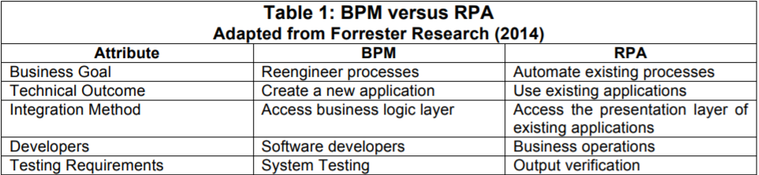

Figure 1: BPM vs RPA, Adapted from Forrester Research (2014) (LeClair, 2017)



Figure 2: The popularity of robotic process automation has skyrocketed in recent years. Source: Google Trends (HELPSYSTEMS, 2017)

## 2.3 What is a software robot?

The software robot is not actually a physical robot nor a normal software, but it has the characteristics of a virtual human that can execute actions the same way an employee does. It can be instructed very quickly to carry out operational procedures at the speed of a machine (Willcocks, et al., 2015) which can be the similar interpretation by HelpSystems describing the concept of a software robot “A robot can be installed on a PC, a physical server, or a virtual machine. Some RPA vendors also use the term robot to refer to an automated process, or even to each occurrence of a process, although these definitions are less common. It’s important for a prospective RPA buyer to clarify with the vendor what a “robot” means to them.” (HELPSYSTEMS, 2017)

## 

## 2.4 Target sector for RPA

The target sector for RPA is relatively limited due to the nature of the process application, the process should be structured, rule-based and repetitive with high to medium volume. Some of the sectors that fit with these limitations are for example:

Financial Services and banking: from the input of customers data into new accounts to processing credit cards applications to distributing records. Slow moving financial institutions face increasing pressure to respond to customer requests and RPA has can quickly and accurately manage high-volume data transfers and other processes across complex infrastructure, as described by (HELPSYSTEMS, 2017).

Healthcare: Due to sensitivity and high regulation of the healthcare industry it requires reliable transmission of sensitive data throughout a wide network of departments and partners. As records must be up to date and synced between providers, labs, pharmacies and more. Here is where RPA can be of ideal fit in terms of moving and manipulating data between different systems. RPA is used for patient file update, claims processing, appointment scheduling and more as described by (HELPSYSTEMS, 2017) which is supported by Forrester, confirming in 2016 the acquisition of Trizetto, a health claims platform provider by Cognizant which is one of the major RPA service providers. (LeClair, 2017)

Insurance: High volume of paperwork and complicated workflows is a common issue for insurance companies. A potential customer requesting a quote - an action that seems simple enough from the consumer’s perspective—triggers a series of processes that may involve disparate data sources and legacy systems. RPA easily handles this and other insurance processes. (HELPSYSTEMS, 2017)

Retail: In retail, RPA is likely to be used for back-office tasks like order processing and inventory management. RPA’s flexibility helps manage processes for stores on a different schedule.

Manufacturing: Physical robots are dominating the manufacturing industry. Software robots are a natural fit for back-office processes like procurement and inventory management. RPA can increase productivity and reduce time to market. As ERP-system is the backbone of any manufacturing company, RPA can interface with ERP software for comprehensive data integration and custom reporting options that may ERP capabilities not able to provide.

High-Tech and Telecommunication are determined by the quality of provided customer service, they also have a high volume of repetitive back-office tasks and process which makes it a good candidate for RPA. (Institute, 2017). Another good candidate of RPA as per Helpsystems (HELPSYSTEMS, 2017) is the energy and utilities since they are heavily regulated and at the same time have a huge impact of the quality of life of the people. In a study by CAPCO (Institute, 2017) a major financial institution has vastly reduced manual human intervention by 35% FTE.

## 2.5 Implementation of the RPA

As per CAPCO (Institute, 2017), there are steps taken towards an RPA implementation:

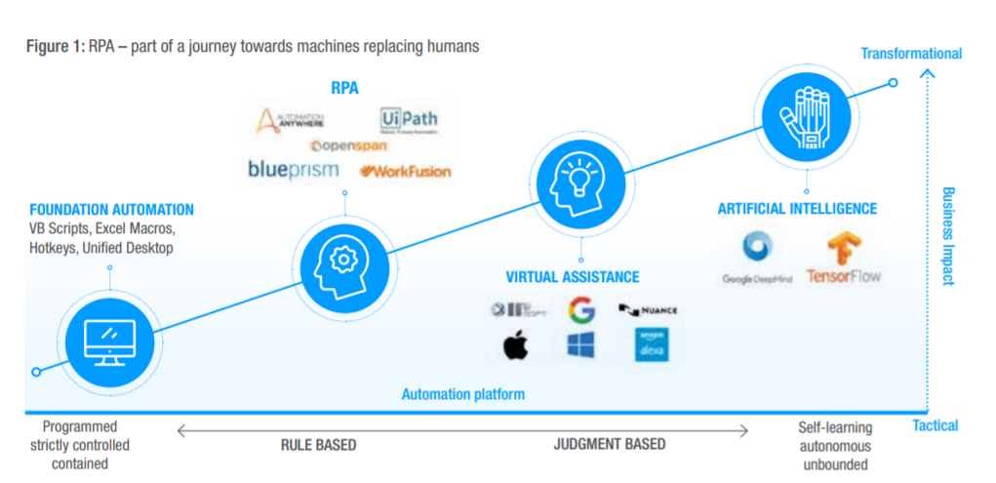

Figure 3: Part of Journey towards machines replacing humans (Institute, 2017)

When considering implementing an RPA solution for the organization there many considerations must be taken and factors to be counted with as CAPCO has surveyed few organizations on the best approach of implementing this technology they came with the following feedback and findings of what organizations consider:

1. They focus on the process, not the technology
2. They are understanding the business problem they are trying to solve
3. They involve technology stakeholders in their automation efforts
4. They are patients to see results and to have an immediate impact on the ROI
5. They proactively manage and don’t “set and forget”
6. They leverage their existing technology (Institute, 2017)

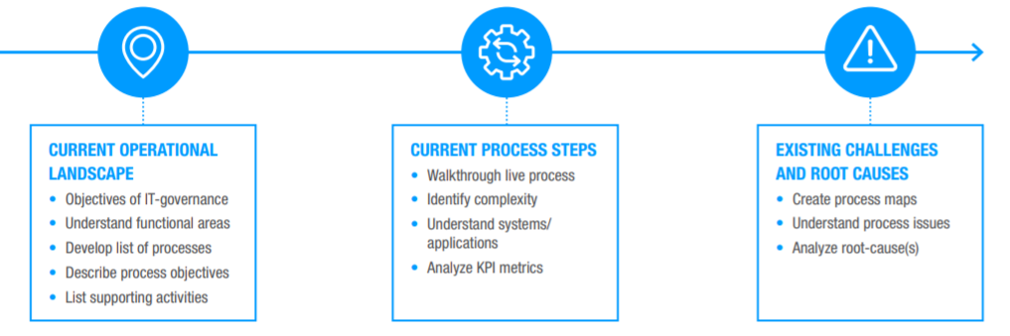

Figure 4: Structured approach to process optimization (Institute, 2017)

In another suggestion by one of the specialists in business digitization, robotics and AI transformation, Pascal Bornet (Bornet, 2017) gives the different general and systematic approach of the journey towards automation:

1. THE FUNDAMENTALS

- A strategic transformation, sponsored by C-level

- Clear vision and business case set at the enterprise level

- Use of the right governance, combining business and IT

- Delivery by a centre of excellence (COE), which is also in charge of innovation

- And maintenance by a robotic operation centre, separate from COE

1. THE ESSENTIALS
   1. Leadership and overall direction

- Appoint a senior head of intelligent automation with the appropriate authority to be able to initiate and sustain the change

- sustainable, flexible and focused on innovation

2.2 Getting prepared, anticipating

- Start with a processe’s automation assessment

- Don’t spend too much time on vendor selection

- Anticipate IT requirements

- Selection of consulting and delivery partner to be considered

- Updated existing process documentation

2.3 Scaling the initiative

- Four essential skills are required: knowledge of business processes (understanding of them at keystroke level), knowledge of how to configure a robot using a certain vendor, use of the right delivery methods (e.g. agile), and experience on similar projects (such projects being so specific by their nature, ensure that at least 30% of the team, internal employees or external consultants, have already worked on similar projects)

- Apply delivery methodologies (e.g. agile) which bring flexibility, structure, and ensure delivery on time, on budget, and with high-quality standards

- Avoid targeting to automate too many activities in one process

- Review and optimize existing processes before robotization

- After migration to production, manage with anticipation the changes to robot configurations required by evolutions in the IT environment (e.g. impacts of changes in the systems used by the robots)

- Consider the opportunities to create synergies by combining back-end traditional robotic process automation with front-end cognitive automation to generate additional efficiencies and customer experience enhancements

- In this fast-paced change environment, it is critical to establish knowledge transfer mechanisms. The easiest starting point is to hire experienced employees and/or consultants to set the right tone and possess a body of strategic and tactical knowledge

- Thrive to identify the Apex point before scaling. There will be a learning curve

2.4. Change management and talent management

- Ensure appropriate change management and the right communication

- Train and educate people in the company to the largest extent possible

- Anticipate the impact on the workforce and the organization: workplace dynamics, culture, employee communication, labour relations, and organization structure

- Take advantage of working with robots to push boundaries. Accelerate team performance through the development of new digital competencies and leadership styles. (Bornet, 2017)

(Willcocks, et al., 2015) in their research have summarised the implementation based on RPA case studies lessons:

1. Establish Business-RPA alignment
2. Define the organizational design and the role of Head of RPA
3. Form an RPA Governance board to manage the demand pipeline and assess RPA

opportunities

1. Agree on the RPA delivery methodology, and the tracking of its correct use
2. Establish the RPA service engagement model required to support operational

processes

1. Define the people, their roles and responsibilities, and provide the training they need

for operating efficiently in the existing organisational structure

1. Define a scalable, low maintenance technical environment and associated growth

strategy

1. Plan for Scaling.

Blue Prism, one of the major market leaders in RPA have adopted own methodology in terms of implementation and delivery methodology which can be summarised in the figure below (Willcocks, et al., 2015):

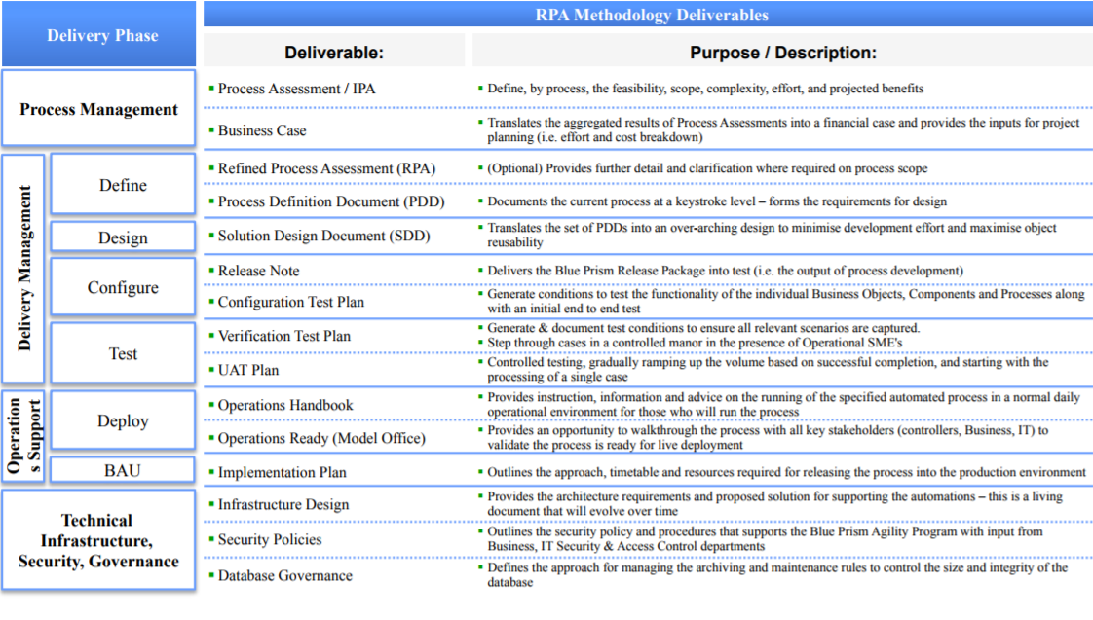

Figure 5: Delivery Methodology – Key Deliverables (Willcocks, et al., 2015)

As the above approach is more general rather than specific to each type of business and industry, I believe there should be more specific methodology depending on the industry to be more funnelled into the details and tackle any roadblocks or any issues that might arise.

## 2.6 Benefits (Advantages) of RPA

CAPCO (Institute, 2017) has summarized some of the main advantages of implementing RPA, however the advantages are considered as a direct impact on the business organization, they maintain that RPA can bring quick productivity gains within weeks, or a few months, i.e., almost instant cost cuts which contradicts with some case studies and survey results mentioned in the implementation section above by them in the same study when they advise that organizations have to be patient when expecting immediate results (Institute, 2017) this finding is also supported by other research by (Willcocks, et al., 2015), unless if the focus was on the relative timeframe since it is suggested that the results can be seen in months and not years which is not a strong case of argument since businesses now are striving for short term gains and do not wait years to see results of their investments. They also maintain that other benefits can be that upfront investment costs and license fees are small and can be calculated reliably, as can the return on investment (ROI). RPA is also suitable as a tactical interim cost-cutting solution if the strategic technical solution is still too expensive. The robots can work 24 hours a day, 7 days a week. No, or minimal, process changes are needed, though the introduction of RPA can trigger process improvements. In addition, no, or minimal, application changes required, and it is scalable and benefits from economies of scale. RPA provides improved quality output compared to human workers, in terms of lower failure rate and risks.

## 2.7 Disadvantages of RPA

Some of the fallbacks and disadvantages for having an RPA solution as maintained by CAPCO (Institute, 2017) was that; new IT architecture feature (the robots) need to be serviced rather than a strategic layer integration, new IT systems (the robots) require new IT security coverage. Also, RPA reduces business case for a strategic solution and, therefore, may delay the strategic solution. Due to this evolving technology, it is currently still for routine work only, which means standard processes need to be cut out of the end-to-end process logic to be automated by RPA. This suggests that the resulting fragmented part of the end-to-end process still needs to be serviced by human workers. Depending on the individual process management layout, this can increase process complexity for human workers. This can mean more setup times at the interfaces between RPA-process parts and human worker process parts, which could mean more failures on the human side. Some of the negatives also that, this technology is currently for paperless work only; data needs to be digitized and once automated, processes are out of sight and can, therefore, shift out of focus for process improvements. In a few words, RPA is just this – automation. It does not trigger or replace the surge for new digital business models. Robots need to be supervised; the work does not just vanish. New tasks emerge with RPA. We should also consider some legal issues may emerge if functional user IDs of robots are misused. Finally, there is a social impact of RPA implementation on workforce needs to be considered as this area of concern which has huge importance, has not been fully researched and investigated as for businesses the win and making profits is the main demeanour. The following quote is taken from CAPCO (Institute, 2017) research where they outlining some falls of the RPA technology “ Early RPA adopters have managed to achieve significant economic benefits, but many more have run out of steam when trying to scale their initial pilot or proof of concept” (Institute, 2017).

CAPCO also refers that to the strong negative opinions from individuals and organizations impacted by media messages about robots stealing people jobs “Robots to steal 15 million British jobs in coming decades, warns Bank of England boss” was one of the headlines in newspapers across the UK in December 2016 (Institute, 2017).

# Research Methodology

## 3.1 Background

To answer the given research questions, quantitative and qualitative methods were the most appropriate methods to be used as per previous research conducted by Forrester (LeClair, 2017). A survey was designed to measure both quantitative and qualitative targeted group of the survey with priority to quantitative methods to measure the level of the awareness. In comparison to the Forrester (LeClair, 2017) survey that follows up the survey with a call to measure the capability of the RPA vendors and evaluates their criteria. Other research by CAPCO (Institute, 2017) was built on case studies to measure feasibility for implementation and it was mostly conducted for commercial uses. This survey was targeting business professionals who are working in organizations and the business sector.

This method was conducted to capture three dependent factors:

1. The awareness of RPA technology;

2. The feasibility and tendency to implement this technology if the awareness was verified;

3. The impact of implementing this (RPA) technology within the respondent’s work environment and measure their reaction or their mitigation plans in case of any.

## 3.2 Survey (questionnaire) design

The survey was designed using SurveyMonkey for its digital capabilities and as a tool that provides data and comparison relationships and analytics. The survey was designed to be very simple consisting of seven questions that would take a very short time (2 minutes on average) to complete and the reason behind this was to have a high completion rate. The survey is 85% of a quantitative nature, hence, the first aim of this survey is to verify whether the respondent is aware of this technology (RPA). The other 15% is of qualitative nature to measure the thoughts and reactions of the respondent and any social impact and risk that this technology could cause. The following is a breakdown of the questions and the reasoning behind them:

* Question 1 (Have you ever heard of RPA (Robotic Process Automation?)

was the most important and the goal is to get information about the level of awareness of such technology. The respondent is prompted to choose between YES/ NO. If the answer was no, then the level of interest would be measured in question 3 and question 4 to see if there is a social tendency to adopt such a technological solution.

* Question 2 (If YES, how knowledgeable are you about this concept? -considering (1) the least and (5) the most-)

This question is dependent on the first question and the goal is measuring the degree in which the respondent is knowledgeable about the RPA technology. The respondent was given a choice of scale score between 1 and 5 to point their degree of knowledge.

* Question 3 (Have you considered suggesting/implementing it within your organization?)

The question is measuring if the respondent would suggest or implement (depending on the authoritative level they have within the organization or by the ability to provide suggestions) this technology (RPA) within their organization. The answer was designed to multiple choice of YES/ NO or if the respondent not sure if the solution would fit for their type of organization and they require a PoC (Proof of Concept).

* Question 4 (If you never heard of RPA, how likely would you consider implementing an IT-solution that maximizes the ROI*,* increases productivity and reduces the operational cost of your business organization? -considering (1) the least and (5) the most-)

This question is of a quantitative nature and is trying to measure any perceptions, criticism towards adopting the robotic process automation technology given that the respondent is not aware of the technology and its capabilities, but they consider adopting innovative and technical advances within the workplace. The answer is given on a scale from 1 to 5 to measure the level of interest.

* Question 5 (Do you think that RPA will reduce manpower and replace them with machines to perform the required work?)

Question 5 is touching one of the most controversial issues of the current situation in the technological era which questions the replaceability of humans with machines to perform the required tasks or that the technology will create more and diverse new types of jobs the same as the situation when the industrial revolution created new jobs despite the fear of losing jobs at that time. The answer to this question is (YES/ NO/ I DON’T KNOW).

* Question 6 (Are you concerned about losing your current work to machines in the future?)

It is of similar nature as for question 5, the difference in this question that it is more personal to the respondent’s perception and it is measuring the social impact of technological advances.

* Question 7 (what are your thoughts regarding your current work, and would you change your career in case it is threatened by current advancement in technology?)

As this is the last question of the survey, and the aim of this question is to provide more qualitative data and insights from the respondents regarding their future fears of technological advances and capture any future reactions the respondent would make in order to adapt to new trends in technologies. The question was not mandatory to respond to as it would reduce the completion rate of the survey.

## 3.3 Participants and sample selection

C-level management in the organizations that could be potentially feasible for implementing an RPA solution. Other respondents were employees in different levels who would have insights and are working within organizations and businesses that are most likely office environment driven. The survey granted anonymity to all respondents.

## 3.4 Survey delivery

The delivery of the survey was by placing a hyperlink that leads to the SurveyMonkey website on a Facebook page and then advertising the survey using Facebook ads and digital media marketing techniques with the following specs:

Period of advertising and survey period: 27th of May 2019- 1st of June 2019.

Age group: The age 25-50, Women and Men. The age 25, is the age groups that are more to be impacted with this new technology, mostly they already have some years of experience working with old routine principles when the RPA technology suddenly introduced causing a shift in business processes management. The age 50 is the age group that will have the hardest effect as they mostly threatened to lose their jobs as a result of old industry design of workflows. An example is bank clerks, processing agents and high-volume routine tasks executers.

Interest targeting: Business and Industry as it is the focus and the implementation scope.

# Results and Findings

(N=58)

Q1.

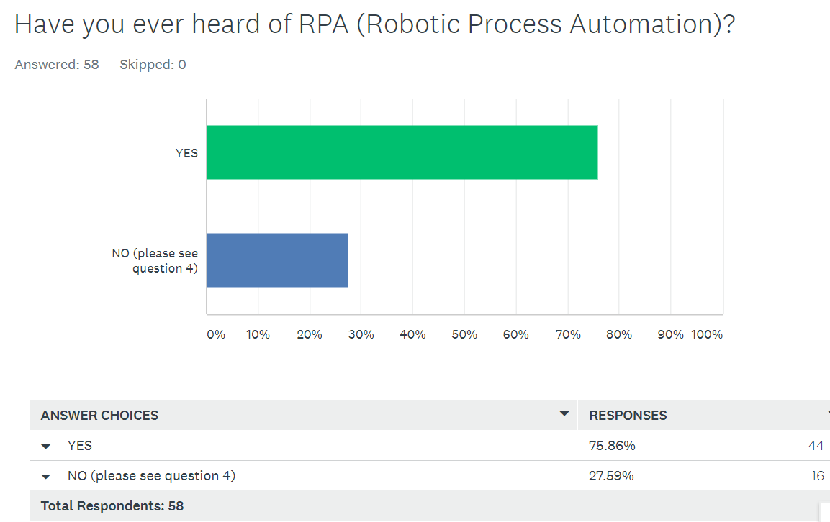

Figure 6: Survey Results - question 1

Q2.

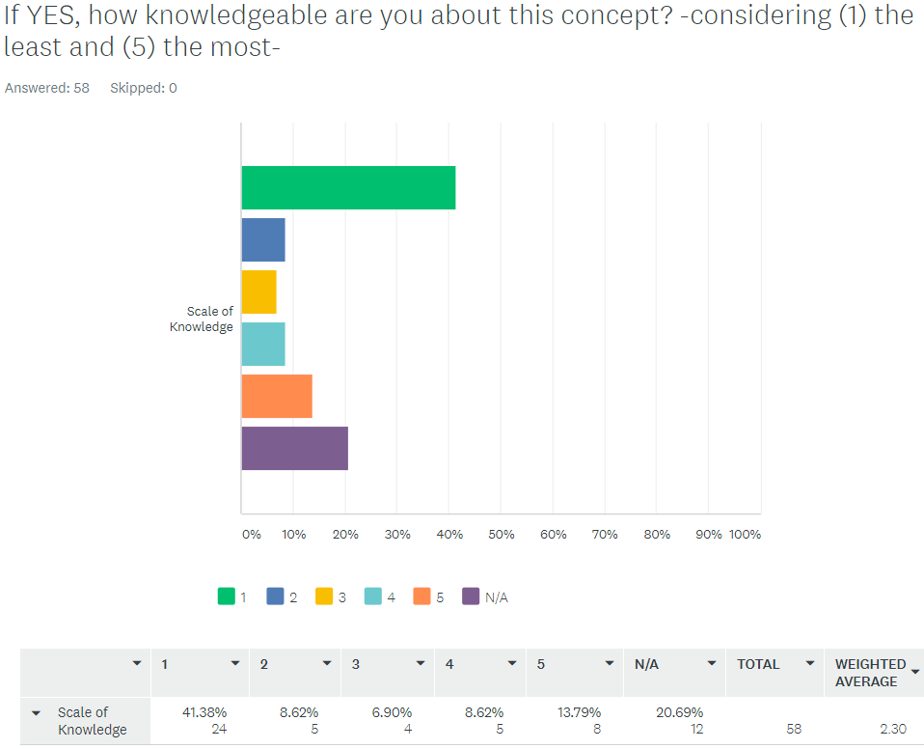

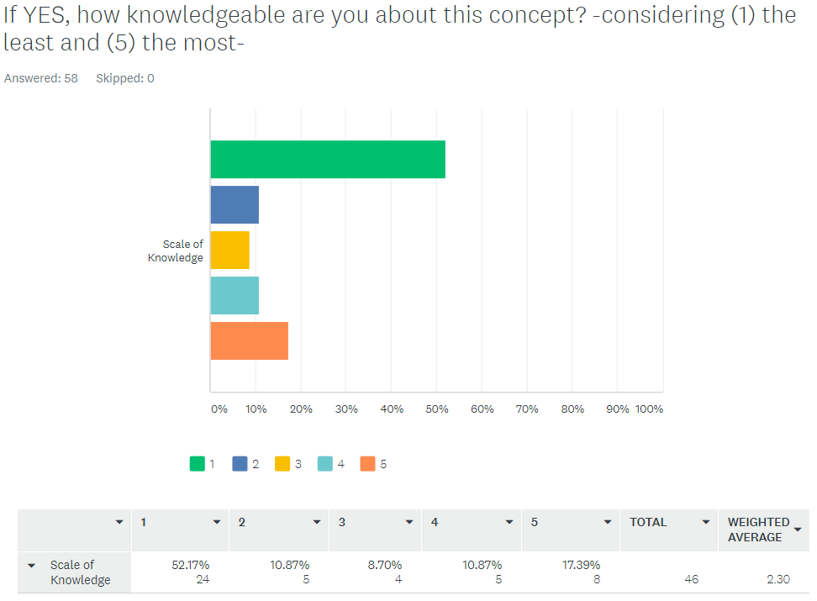

Figure 7: Survey results - question 2

Q3.

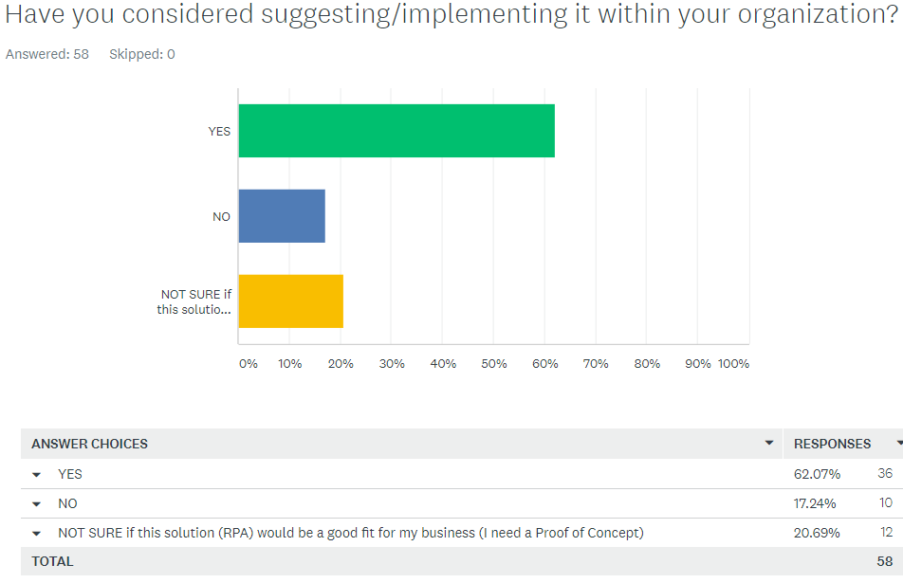

Figure 8: Survey Results - question 3

Q4.

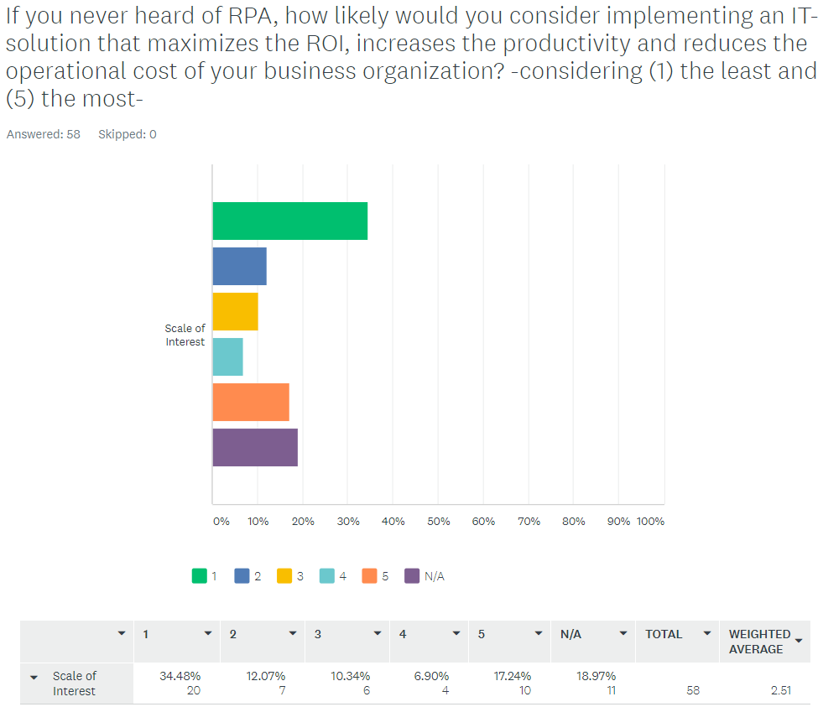

Figure 9: Survey Results - question 4

Q5.

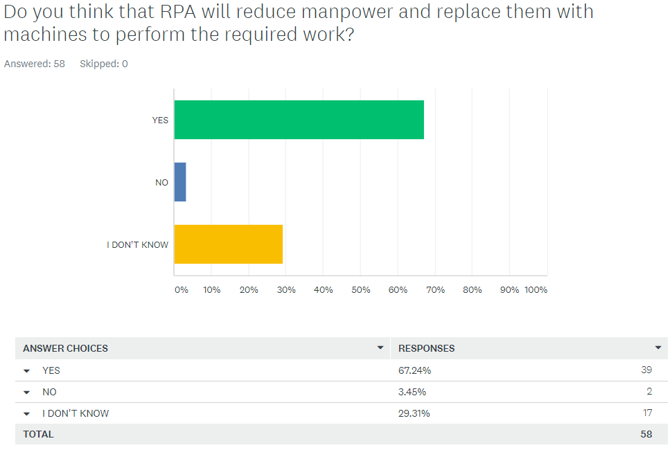

Figure 10: Survey Results - question 5

Q6.

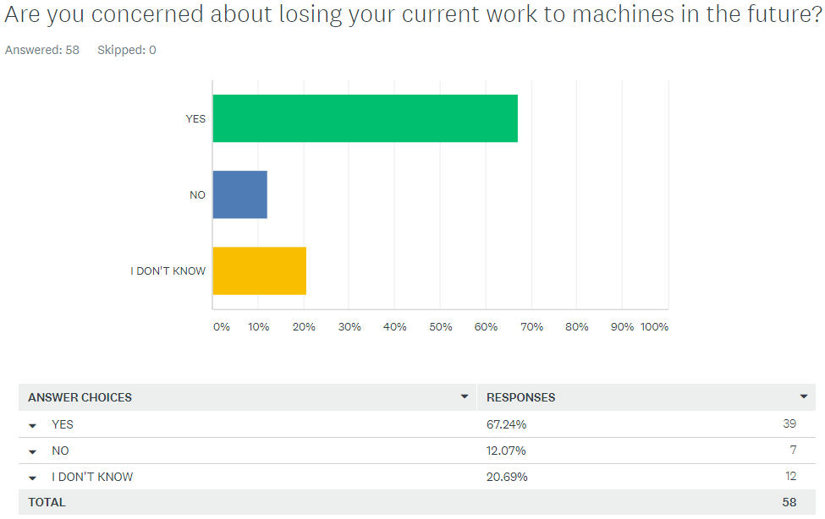

Figure 11: Survey Results - question 6

Q7.

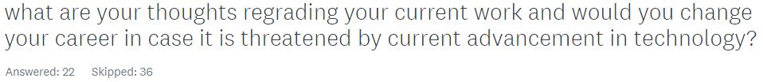

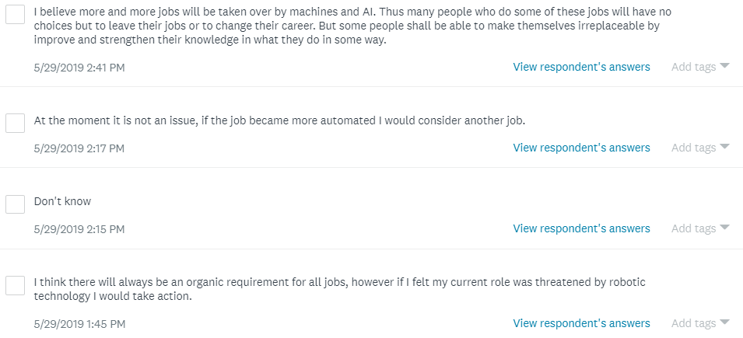

Figure 12: Survey Results - question 7

# Discussion of Results

## 5.1 Introduction

The results of the survey show that 58 individuals have taken and completed the survey (n=58), as per the reporting by SurveyMonkey. However, there could be a margin error due to some error in reporting the results of the first question in a number of respondents, other resulting errors can be related to miss-interpretation of the questions asked or not adhering to the guidelines for answering the survey. This error rate can be eliminated and wouldn’t have an impact on the reliability of results as the stressing factor considered the relationship between different answers from the respondents.

## 5.2 Figure 6 – Survey question 1

As (figure 6) results describe the percentage of people who are aware of the existence of RPA technology. 75% of the respondents claim they are aware of this technology while 25% of respondents said that they never heard of it. Such finding is potentially accurate as this disrupting technology has been recently introduced to the market in the last five years. While earlier in the research it has been pointed out that it has been a confusion in the perception of RPA (Robotic Process Automation) technology in the industry sector to what extent this technology can be defined. This confusion might be related to the similarities of nature between RPA and BPM methodologies. However, the awareness of this technology can be satisfied therefore that one in three people (1:3) are aware of the concept of automation.

## 5.3 Figure 7 (a) and (b) - Survey question 2

It is concluded that there has been an error in interpretation on how to answer the second question in the survey despite a clear direction and the two logical options suggested to skip this question once the answer was (NO) to the first question. As the options were alternatively to move to (question 4) or choose (N/A) as an answer. Thus, the margin error can be very limited and eliminated. More than half (52.17%) of the sample who claim to be aware of the RPA technology consider their knowledge of it to be very limited scoring 1 on a 5 points scale. While the extreme value of 5 on the scale shows that (17.39%) to have an expert knowledge was surprising as compared to the value 2 (10.87%), value 3 (8.70%), and value 4 (10.87%), as a result, we could potentially draw a result that more and more people are skilling themselves up towards more technical abilities. Consequently, this shows a building gap in the skills which might potentially cause loss of jobs in a radical way if there are no actions taken by the society bridge this gap. In terms of implementation, the results also point out that the knowledge base is building up of how to find a standard way of implementation.

## 5.4 Figure 8 - Survey question 3

Results suggest that the respondents of the survey don’t consider this technology as a threat to their current jobs, as their tendency and involvement of suggesting the implementation of RPA technology within their organization is high. Adversely, a part of the (YES) answer might not be fully aware or lack competent knowledge of how Robotic Process Automation implementation might be impacting their current situation at the workplace. Another fold that is explored in this question was the significant number of respondents that are not sure if this technology would be scaled to the organization they work within, but they are willing to see it implemented within the organization, or the respondent is coming from a background where there non-value and high repetitive tasks involved in the business model the company or organization has. There also a considerable number of the respondents which estimated to be 20% require to have a proof of concept (PoC) as a showcase of success for this technology due to the fact many organizations have had difficulties in implementing such technology as referred earlier in the research under the disadvantages of RPA that many companies ran out of steam when they tried to implement or perform a PoC (Institute, 2017).

## 5.5 Figure 9 - Survey question 4

There are a clear concern and suspicion towards having new technologies implemented and integrated within workplaces. This concern is mostly related to the fear of losing the job or could be referred to the human nature which rejects the change. Despite the benefits that RPA technology brings to the environment of work with few examples outlined in the question in the survey which includes increasing productivity and return on investment, which in return grants the business continuity, there is lack of interest in considering RPA as a technological enhancement. This is reflected by a third of the total surveyed sample.

## 5.6 Figure10 - Survey question 5

Almost two-thirds of the respondents (67.24%) of question five in the survey have agreed that RPA technology would reduce manpower and replace them with machines to perform the work they required to do. There were respondents that disagree with this statement, they believe that RPA and machines won’t replace the need of human manpower as (3.45%) of the reviewed sample chose (No) answer. However, this is a very small fraction.

## 5.7 Figure 11 - Survey question 6

The question (6) in the survey discusses the personal impact by the general adoption of technology and the shifting towards more digitalised and automated society controlled by machines. It reflects the level of concern of the individuals and the fear of finding themselves at the point where they are no more required to perform their duties and being jobless. While the preceding question of the survey was more of measuring the knowledge of RPA and its application. The same percentage and number of respondents in has agreed to that they are going to lose their jobs as a result of technology advances. The difference was in the scale of knowledge of RPA and the resources it requires for implementation. This agrees with what was earlier presented in the study under the disadvantages of RPA as media in the UK in 2016 refers to stealing jobs by robots (Institute, 2017).

## 5.8 Figure 12 - Survey question 7

In answering the last question of the survey, which was included for qualitative measures, many respondents chose to skip this question and exit the survey. Few answers from some of the respondents have indeed provided some insights in regard to their thoughts about advancement in technology and how it affects their career choices. One of the respondents provided the following statement “I believe more and more jobs will be taken over by machines and AI. Thus, many people who do some of these jobs will have no choices but to leave their jobs or to change their career. But some people shall be able to make themselves irreplaceable by improving and strengthen their knowledge in what they do in some way.” (Respondent #24). The same respondent has indicated earlier in the survey that they would highly (respondent answer score was 5) suggest the implementation of the RPA technology within their organization, despite no prior knowledge of RPA. The respondent also is concerned to lose their job to machines and advances in technology. Another respondent states “At the moment it is not an issue, if the job became more automated, I would consider another job.” (Respondent #23) who is very knowledgeable (5) of RPA. Some of the respondents that have no prior knowledge of RPA would suggest this solution to their business organization and they are not concerned of losing their jobs in the future as a result to automation they believe that “ I think there will always be an organic requirement for all jobs, however, if I felt my current role was threatened by robotic technology I would take action.” (Respondent #20).

A result from (respondent #18) was unexpected but most likely explains the current trend in the market and the rapid change and evolving in technology concepts. The respondent never heard of RPA. They are reluctant to recommend it as they require proof of Concept and implementing it within their organization was not very high (the respondent scored 3), the unexpected was that the respondent is currently working on automation with no further specifics provided. Despite this was unexpected, it is suggested by research that it is still not uncommon as per (Willcocks, et al., 2015), there is a misperception in regards to RPA and it doesn’t necessarily need to be tied to automation in its core mechanism since RPA is designed to operate on the user interface level under the umbrella of BPM.

# Conclusion and Recommendations

## 6.1 Conclusions

From this carried out research and surveyed sample, we could clearly see that:

* There is a lack of knowledge in relation to the concept of RPA (Robotic Process Automation) among business and industry professionals.
* The implementation of this technology is not standardised due to the continuous evolving of the methods and techniques used to implement this technology as concluded from the literature review used in this study. Also, the different industry backgrounds can contribute to the need for different requirements for implementation in each sector.
* Despite the benefits the RPA brings. There is a reluctance in adopting this technology by both industry leaders and manpower. The Literature review has pointed out that it could be a complex solution that drains resources and might fail for early adopters.
* There is no evidence that RPA would neither reduce nor increase jobs in the future, as this matter is left to the future to be determined and measure the impact.
* Professionals are willing to see new technologies adopted in their organizations despite the fear of losing their jobs. They believe there are always many ways to overcome technological advancement. These ways can among others be by upskilling themselves to the level that there is always a need for them, or they believe that there is always an organic need for human manpower.

## 6.2 Recommendation

* There is a need to involve the employees in educational and developing programs that enhance their technical and IT abilities to cope with advancements in technology. This can result in the allocation of the current talent to perform different tasks that are important and more creative in nature instead of losing the talent and the experience they gained about different areas of the organization that are not replaceable by robots or machines.
* RPA promoters and vendors need to introduce a programme of integration of employees together with the solution package they sell to the targeted companies instead of focusing on the technical solution itself. This would increase the value and return on investment for both the vendor and the targeted organization.

# Bibliography

Bornet, P., 2017. *How to Succeed in your Intelligent Automation Journey, involving RPA, artificial intelligence, chatbots and cognitive?.* [Online]   
Available at: https://www.linkedin.com/pulse/how-succeed-your-intelligent-automation-journey-pascal-bornet  
[Accessed 2nd January 2018].

HELPSYSTEMS, 2017. *What is Robotic Process Automation.* [Online]   
Available at: https://www.helpsystems.com/blog/download-robotic-process-automation-guide  
[Accessed 31 12 2017].

Institute, H. U. B. S.-. (., 2017. Automation. *The CAPCO Institute Journal of Financial Transformation,* 11(46), pp. 54-62, 104-116.

LeClair, C., 2017. *The Forrester Wave™: Robotic Process Automation.* [Online]   
Available at: http://www.bluvaultsolutions.com/wp-content/uploads/2017/11/Robotics.pdf  
[Accessed 1 January 2018].

Willcocks, L., Lacity, M. & Craig, A., 2015. *The IT Function and Robotic Process Automation.* [Online]   
Available at: http://eprints.lse.ac.uk/64519/1/OUWRPS_15_05_published.pdf  
[Accessed 01 01 2018].

Frey, C. B., and M. A. Osborne, 2013, “The future of employment: how susceptible are jobs to computerization?” report, Oxford Martin School, University of Oxford, http://bit.ly/2yym1vt

Greer, S., and C. Beattie, 2016, “Robo op - how robotic process automation is applied in banking operations,” Celent, November 28, <http://bit.ly/2wNThzb>

Le Clair, C., A. Cullen, and M. King, 2017, “The Forrester WaveTM: robotic process automation, Q1 2017,” Forrester, February 13, <http://bit.ly/2kaojyt>

Rosenfeld, E., 2017, “Deutsche Bank CEO gets brutally honest about what automation is going to do to banking jobs,” CNBC.com, September 17, <http://bit.ly/2xH0zXu>

Rürup, B., 2017, “Abgabenbescheide für roboter,” Handelsblatt, May 2, p.12, http://bit.ly/2fXHDL5 Tornbohm, C., 2016, “Market guide for robotic process automation,” Gartner, November 7, http://gtnr.it/2nV6XG8

# Appendix

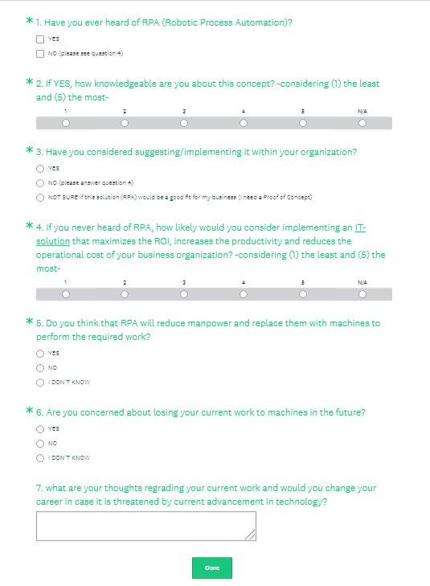

Figure 13: The Survey used in the research

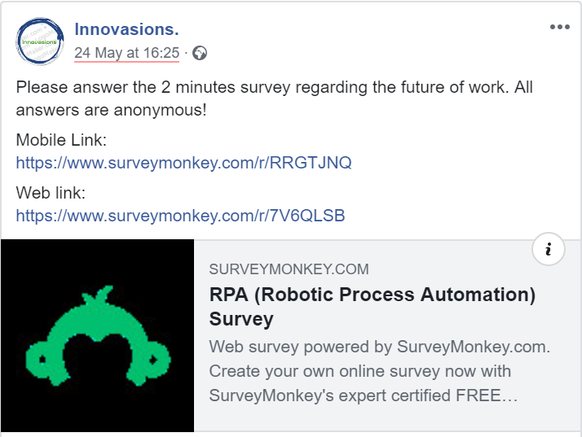

Figure 14: Placement of the Survey